# WORK EXPERIENCE

Sales & Marketing Manager - Fresh Station Croup

January 2019 - August 2019

* This includes PR, Print, Digital, Events, Social media, Influencer marketing and also direct marketing campaigns
* Developing Social Media marketing strategy
* Brand Building strategy • Overall understanding of pre-sales and post sales procedures

Manage in-person and telephone guest inquiries, customer service requests, and reservation bookings.

* Develop reports with clients and generate repeat business through friendly attitude and extensive knowledge.

Sales & Marketing Assistant Manager - Little Italy Croup

July 2018 - December 2018

* This includes PR, Print, Digital, Events, Social media, Influencer marketing and also direct marketing campaigns
* Developing Social Media marketing strategy
* Brand Building strategy • Overall understanding of pre-sales and post sales procedures

Manage in-person and telephone guest inquiries, customer service requests, and reservation bookings.

* Develop reports with clients and generate repeat business through friendly attitude and extensive knowledge.

PR & Social Media Assistant Manager - Blue Sky

May 2017 - June 2018

* Coverage Reports
* Translation
* Checking press releases
* Media relations
* Providing on ground support at events

|  |  |  |
| --- | --- | --- |
| Farsi | English | Arabic |
| Native language | Speak fluently and read | Intermediate level of writing |
|  | write with high proficiency | and speaking |

* 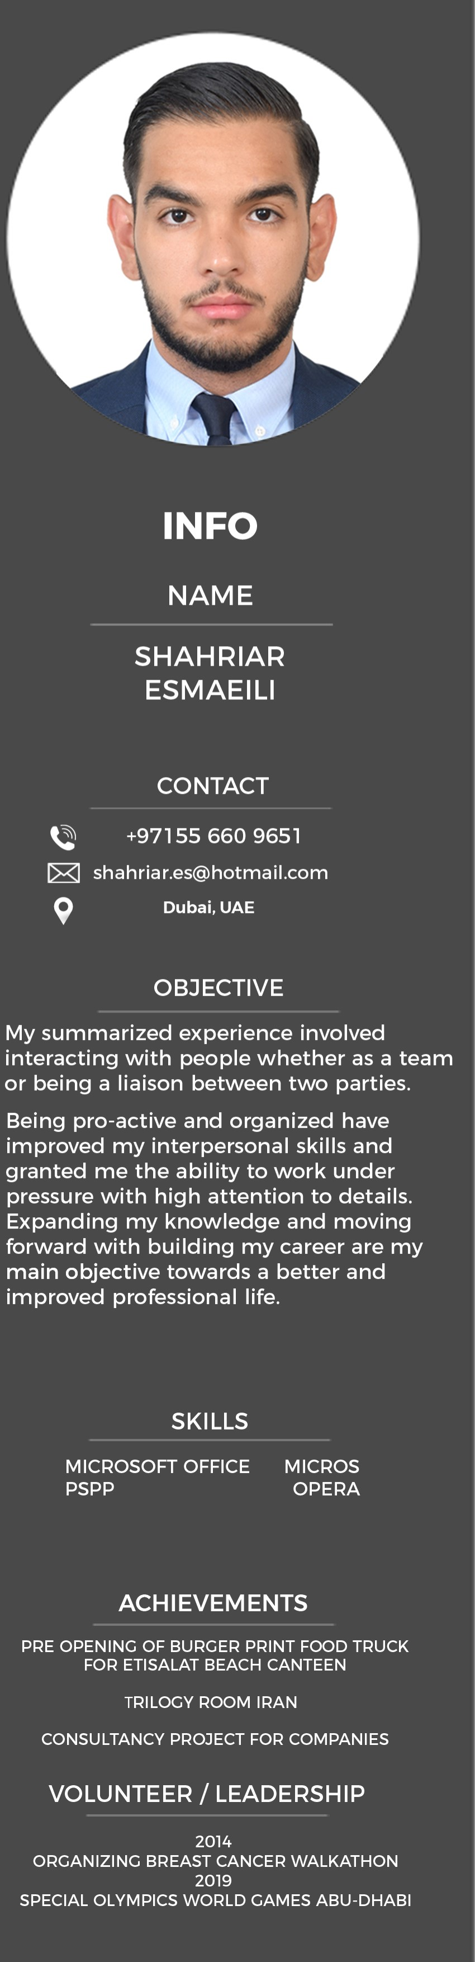Creating posts
* Briefing designers for posts
* Drafting and Translating content
* Creating content calendar
* Community Management
* Account Management
* Client Servicing

Marketing & Cuest Relations Executive - Monaco

October 2016 - May 2017

Implement sales driven campaigns keeping local trends and peak seasons in mind and developing strategic offers to drive footfall. • Managing the contact database and assisting with lead generation activities.

* Maintaining social networking channels.
* Communicating with target audiences, clients and managing customer relationships.

Social Media & Marketing Executive - Lacco Ceneral Trading

November 2015 - February 2016

* Work closely with the Brand Marketing team on UAE specific campaigns and support in adapting them to the region.
* Developing and maintaining a close productive relationship with clients.
* Ensuring client requests are dealt with promptly and that expectations are managed in terms of speed, delivery and quality
* Ensuring client requests are developed into relevant internal briefs using specified company documentation and procedures

EDUCATION

The Emirates Academy of Hospitality Management, Dubai, UAE

Bachelor of Science (Honours) in International Hospitality Management

Al Mawakeb School, Dubai, UAE High school Qualifications

# LANCUACES